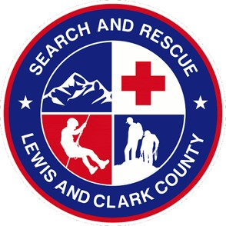
Lewis and Clark County Search and Rescue

Wilderness First Aid
Dec 3-4, 2022 • Helena, MT

Course Overview:
Wilderness First Aid is Aerie’s premiere introduction to wilderness medicine. This 16-hour course is designed for students who have little or no experience in first aid or wilderness medicine. It is well suited for individuals who are responsible for friends and family while in the backcountry as well as professional guides.
The course is designed with scenario at the heart of the learning experience. We emphasize hands on practice of skills and assessments of patients.
The course covers basic emergency medicine topics such as airway management, breathing emergencies, circulatory problems, and environmental concerns. We include common medical emergencies such as diabetes, seizures, asthma, and anaphylaxis. We emphasis trauma with in depth discussions and hands on training with splinting, bleeding control, and wound management. We also discuss legalities within wilderness medicine and SOAP note documentation.
Along with basic medical and trauma concerns we discuss how these emergencies can be addressed in a wilderness environment. This includes topics such as evacuation, litter construction, backcountry communications, and decision-making.
A Wilderness First Aid certification is valid for 2 years. After your certification expires you simply need to retake the class to renew.

Course Objectives (Included but not limited to):
- Scene Safety
- Bleeding control
- HABC
- Diabetes
- Seizures
- Asthma
- Anaphylaxis
- Splinting
- Wound Management
- WFA legalities
- Hypothermia
- Evacuation
- Litter construction
- Communications
- WFA decision making
- Backcountry safety and considerations

Course Agenda:
Dec 3
0745 Registration/Sign in
0800 Course Instruction
1200 Lunch
1300 Course Instruction
1700 Conclusion

Dec 4
0800 Course Instruction
1200 Lunch
1300 Course Instruction
1600 Course Conclusion and Certificates

Course Materials
AERIE Wilderness First Aid Handbook

