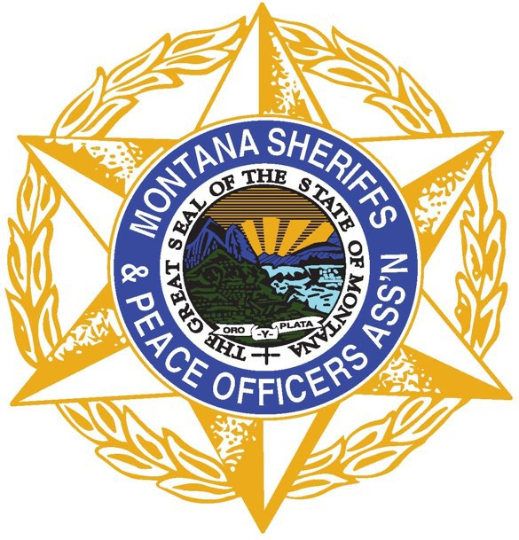

Montana Sheriffs & Peace Officers Association
PO Box 794 • Helena, MT 59624 • (406) 443-5669 • www.mspoa.org

Search and Rescue Subcommittee
HOST AGENCY SAR TRAINING FUNDS REQUEST

Refer to and adhere to the training fund guidelines.

Date of Request:

Name: Title:

Sheriff’s Office Sponsoring the Training:

SAR Team:

Address :

City: State: Zip:

Email: Phone:

Name of Training:

Location of Training: Date of Training:

Projected Training Course Budget:
Company/Presenter Fee $

Presenter Travel (if fee is not a flat fee) $

Presenter Hotel (if fee is not a flat fee) $

Per Diem (#Days x Current Federal M&IE) (if fee is not a flat fee) $
https://www.gsa.gov/travel/plan-book/per-diem-rates

Equipment Necessary for Course $

TOTAL Request Amount $

Signature of SAR Team Leader Signature of Sheriff Approving Application

MSPOA SAR Subcommittee Training Fund Guidelines

- Training must be sponsored by Sheriff’s Office in order to qualify for POST Credit and MSPOA financial assistance.
- The application for training stipend should be made at least 30 days prior to the start of the event.
- Host agency agrees to submit an application for DES Training Reimbursement Funds to reimburse MSPOA for the cost of the training.
- If training is hosted under SAR Subcommittee through MSPOA, no registration fee will be charged to attendees.
- If Host Agency fails to repay MSPOA for financial assistance after receiving the SAR Training Reimbursement through DES, the agency will not be permitted to vote at SAR subcommittee meetings, attend future MSPOA sponsored trainings, or be eligible for MSPOA financial assistance in the future.
- Lodging, mileage and per diem
  - Individual SAR Teams are responsible for those fees through their training budget and/or DES Training Reimbursement.
- The applicant must present cost estimations when applying for the stipend, including:
  - Presenter Training Fee
  - Presenter Travel
  - Presenter Hotel
  - Presenter Per Diem at the Federal Rate
  - Equipment Necessary for Course
- The applicant will be required to include documentation for expenses with the application prior to funds being disbursed.

The purpose of the training funds through MSPOA is to offer SAR Teams the opportunity to provide quality, relevant training, which is often costly, to their own team and other teams in the state. Teams can utilize funding through MSPOA to pay for the required up-front expenses of the training and upon conclusion of the training course, must submit a DES SAR Training Reimbursement request in order to repay MSPOA. Many Sheriff’s Offices and SAR Teams do not have flexible funding to pay required training fees up front.

