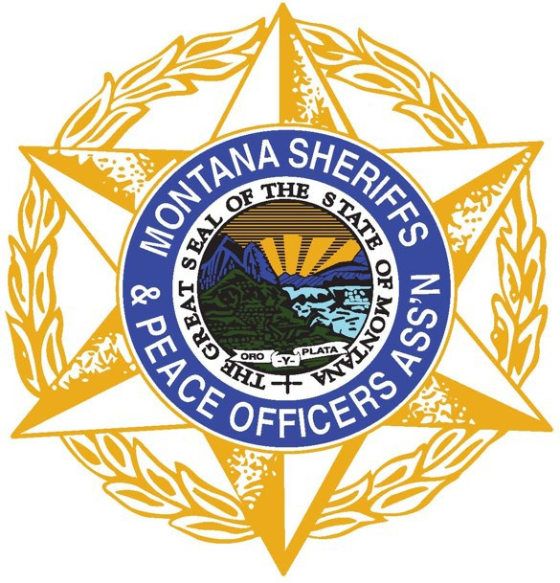

Montana Sheriffs & Peace Officers Association
PO Box 794 • Helena, MT 59624 • (406) 443-5669 • www.mspoa.org

Search and Rescue Subcommittee

Quarterly Meeting

Date: Tuesday, January 11, 2022
Time: 10 am – 12 pm
In-person: Fort Harrison, HAFRC, Room 113
Remote: Via Zoom

MINUTES

Introductions – Jake Ganieany.; Charlie Gorman.; Corey Hansen; R. Michael McCloskey; Skylar Steele (online); Burleigh Curtis (online); Nanette Gilbertson (MSPOA); Scott Secor (Chair); Scott Van Dyken (Vice Chair); Jason Jarett; Erin Metzger; Ralph DeCunzo; Bill Cassell (online); Rick Vaughn (online); Jennifer Thompson (online); Brad Marten; Kent O’Donnell (online)

Review and approve minutes from previous meeting
- Moving forward minutes will be distributed, reviewed and approved
- No minutes found for last meeting.

Old Business (Issues previously discussed which require follow-up)
- None

New Business (Emerging issues which require attention from the SAR Subcommittee)
- Review and approve updated SAR Subcommittee Operating Procedures (Document attached): Collectively reviewed documents and members provided suggestions for 3 Changes: Under bullet #2 add approval/recommendations; DES nomenclature; Members may provide agenda items. – APPROVED UNANIMOUS
- Review and approve updated SAR Reimbursement Request Guidelines (Document attached): Guidelines were reviewed and revised from previous versions the subcommittee discussed. Starting March 1, 2022, reimbursement amounts change due to HB 678, DES & FWP will work to clarify whether funds roll over to the next funding year or get removed from the funds account. – APPROVED UNANIMOUS
- Review of 2021 funds presented by Jake Ganieany. Jake will email a written copy once reconciled with FWP.
- Encourage all SAR Teams to be familiar with the reimbursement amounts, effective dates, and changes to SAR reimbursement per HB 678 (https://leg.mt.gov/bills/2021/billpdf/HB0678.pdf)
Training
- Reevaluate Annual Search and Rescue Rendezvous - Due to effort and financial burdens of host counties, the Annual SAR Rendezvous will no longer take place. Locally hosted training opportunities will be shared with others. Training funds may be used for these training sessions. Nanette and Jake will reconcile funds that were sent to MSPOA by Missoula Co. for the 2021 Rendezvous.
- Identify training needs and opportunities
Opportunities for trainings hosted by SAR teams to be shared with and communicated to other SAR teams around the state.
- MSPOA and subcommittee will continue to explore the best communication mechanism to share training opportunities and reach SAR Teams, including the Sheriff Office Liaison, deputies and volunteer members. Email list, Facebook and a SAR page on the MSPOA website will be explored.

Resource List
- Review and update SAR resource list – Updated list to be distributed to Sheriffs and MSPOA SAR sub-committee annually by Jason Jarett. Chair Secor to ensure that each sheriff in the state is contacted to determine ways to contact SAR groups in each county.

Reimbursement Requests
- Mission – 3 total requests from 2021, all off-road: (1) Gallatin Co. helicopter rescue, $2640, Approved; (2) Gallatin Co. helicopter rescue, $4320, Approved; (3) Lincoln Co. fuel costs for month-long mission, $749.48, Approved.
- Training – 3 total requests from 2021: (1) Gallatin Co. Helicopter training, $4,080, Approved. (2) Gallatin Co. Helicopter team training, $4560, Approved. (3) Gallatin Co. Helicopter avalanche short haul training, $4560, Approved.
- Equipment (will not be reviewed and approved until the end of the state fiscal year)

Public Comment
None

Next Meeting is April 12, 2022 at 10:00 AM – 12:00 PM at DES, Fort Harrison.

Adjourned at 12:04 PM

