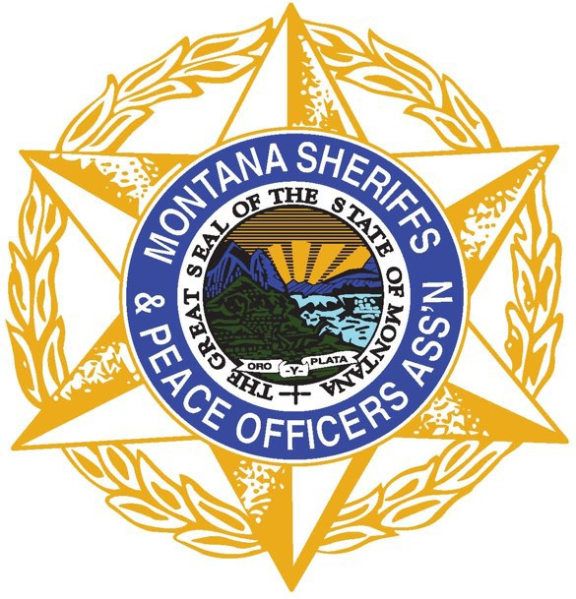

Montana Sheriffs & Peace Officers Association
PO Box 794 • Helena, MT 59624 • (406) 443-5669 • www.mspoa.org

Search and Rescue Subcommittee

Quarterly Meeting

Date: Tuesday, April 12, 2022
Time: 10 am – 12 pm
In-person: Fort Harrison, HAFRC, Room 113
Remote: Join Zoom Meeting

MINUTES

Call to Order
Chair Secor called the meeting to order at 10 am

Introductions Scott Secor (Chair); Scott Van Dyken (Vice Chair); Nanette Gilbertson (MSPOA); Erin Metzger; Jake Ganieany (DES); Charlie Gorman (DES); Corey Hansen; Ralph DeCunzo; Bill Pandis; Kevin Wright; Dave Kauffman; Josh Pallister; R. Michael McCloskey (online); Skylar Steele (online); Lawrence Morrisroe (online); Jason Jarett (online); Kent O’Donnell (online); Alex Peterson (online); Brad Beaulieu (online)

Approval of January Minutes
Motion to approve minutes from 1-11-22 meeting. Second. Approved unanimous.

Old Business (Issues previously discussed which require follow-up)
- Where to post training needs/opportunities? MSPOA Website? Email?
MSPOA to establish a separate website (sarmt.org) as a one-stop shop for statewide SAR information (training opportunities, templates, reimbursement forms), links to teams and resources, cost $2500 covered by MSPOA. Continue email chain also.

New Business (Emerging issues which require attention from the SAR Subcommittee)
- March 1st Reimbursement amount increased to $50,000 cap (for both mission and equipment reimbursement). Does not specifically have to be hunting, fishing, trapping related. Through June 30, 2023. Starting July 1, 2023, the reimbursement amount reverts back to $12,000.
For equipment reimbursement requests, must provide a match amount (65/35). Equipment purchased prior to 3/1/2022 is limited to a capped reimbursement amount of $12,000 and the match percentage is still required.

- Encourage all SAR Teams to be familiar with the reimbursement amounts, effective dates, and changes to SAR reimbursement per HB 678 (https://leg.mt.gov/bills/2021/billpdf/HB0678.pdf)
- Funds Balance: Jake Gainieany - Off Road is $72,781.36; FWP is $61,112.42.
DES offered to create a new submission process for reimbursements via Survey123. The online submission form would replace the Excel document, but still require all applicable documentation to be provided. DES will demonstrate in June and the members can consider what efficiencies and accuracies will be gained via an online submission form.

Training
- As a reminder. Due to the cost, planning, and sheer number of hours required to host the SAR Rendezvous, the MSPOA SAR Subcommittee decided to move away from the Annual SAR Rendezvous to an on-going, regional training model that will allow SAR Teams to attend training on a more regular basis with the other teams in their region. Holding the rendezvous during one week, requires people to pick and choose which training tracks to attend. Conversely, stand-alone regional trainings will permit members to attend a wider variety of SAR specific training throughout the year.
- Identify training needs and opportunities.
A survey monkey will be sent out to the email list requesting rankings of the top topics teams identify as core trainings. The results will guide the decision making process for quarterly SAR trainings.
- Trainings currently scheduled by local SAR Teams
Missoula Co -- ICS 300 – May 18 – 19
Gallatin Co. -- Lost Person Behavior -- TBD
Stillwater Co. -- Basic SAR class -- TBD September (likely Sept. 9,10,11)
Jefferson Co. will forward info on a TTT Coordinator course that they can put on
Cascade Co. -- ICS 300 -- TBD
Coroner’s Association hosting an Aquatic Death Investigations course

Resource List
Review the lists for accuracy. Send Chair Secor corrections.
- SAR resource guide
- SAR contact list
- SAR K9 list

Reimbursement Requests
- Mission-None Submitted
- Training-None Submitted
- Equipment (will not be reviewed and approved until the end of the state fiscal year)
None Submitted
Reimbursements should be submitted before June 14th for this fiscal year. If missions happen after June 14th, they can still be submitted and will be reviewed by email.

Public Comment
None

Adjournment
Meeting adjourned at 10:50 AM.

Next Meeting
- June 14th, 2022

